Hadoop 2.7 Spark 2.0伪分布式安装配置实录

Yao Ran

Nov-2016

目录

1. 软件包列表 3

2. 操作系统安装配置 3

2.1. 安装操作系统 3

2.2. 设置网络 3

2.3. 安装&定制软件包 4

2.4. 配置Java环境 4

2.5. 准备Hadoop用户 4

3. Hadop 2.7.3安装配置 5

3.1. 解压安装包 5

3.2. 配置系统环境变量 5

3.3. 修改Hadoop配置文件 5

3.4. 设置Hadoop用户所有权 5

3.5. 生成ssh授信密钥 6

3.6. HDFS操作 6

3.7. 配置YARN 6

3.8. 启动&测试服务 7

4. Spark安装配置 7

4.1. 解压软件包 7

4.2. 配置Spark 7

4.3. 运行Spark示例 8

4.4. 启动Spark-Shell 8

4.5. 测试Spark RDD 8

5. Hbase安装配置 8

5.1. 解压软件包 8

5.2. 配置Hbase 8

5.3. 启动停止Hbase 9

5.4. Hbase Shell操作 10

6. PostgreSQL安装配置 10

6.1. 解压软件包 10

6.2. 创建用户 11

6.3. 编译安装 11

6.4. 配置环境与数据库 11

6.5. 配置系统服务 11

6.6. 测试数据库使用 11

6.7. 配置远程访问 12

7. Hive安装配置 12

7.1. 解压软件包 12

7.2. 配置环境参数 12

7.3. 准备Meta Store 13

7.4. 配置Hive 13

7.5. 配置HiveServer2 14

7.6. 启动停止Hive服务 15

8. Hive使用及进阶 16

8.1. Hive使用 16

8.2. Hive与Hbase集成 18

8.3. Python 3访问Hive 18

9. Sqoop安装配置 18

10. Pig安装配置 18

11. Presto安装配置 19

12. Tableau使用Spark SQL案例 19

## 软件包列表

|  |  |  |
| --- | --- | --- |
| **软件包名** | **下载地址** | **说明** |
| jdk-8u65-linux-x64.tar.gz | Oracle OTN | JDK |
| hadoop-2.7.3.tar.gz | http://ftp.wayne.edu/apache/hadoop/common/hadoop-2.7.3/hadoop-2.7.3.tar.gz | Apache Hadoop |
| hbase-1.2.4-bin.tar.gz | http://www.apache.org/dyn/closer.cgi/hbase/ | Hbase |
| postgresql-9.6.1.tar.gz | https://www.postgresql.org/download/ | PostgreSQL(Hive Metastore) |
| postgresql-9.4.1212.jar | https://jdbc.postgresql.org/download.html#current | PostgreSQL JDBC |
| apache-hive-1.2.1-bin.tar.gz | http://hive.apache.org/ | Hive |
| apache-hive-1.2.1-src.tar.gz | http://hive.apache.org/ | 编译Hive-Hbase集成使用 |
| scala-2.11.8.tgz |  | Scala |
| spark-2.0.2-bin-hadoop2.7.tgz |  | Spark |
|  |  |  |
|  |  |  |

## 操作系统安装配置

### 安装操作系统

* **安装CentOS 6.7**

将最大的空间划分到/opt卷下

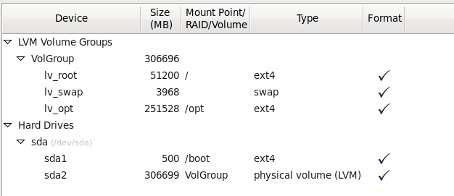

最小化安装CentOS 6.7

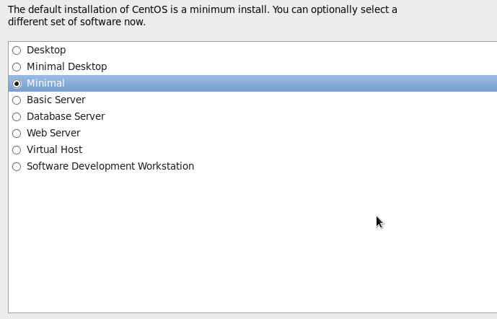

### 设置网络

* **关闭防火墙服务**

|  |
| --- |
| [root@que01 ~]# chkconfig iptables off  [root@que01 ~]# chkconfig ip6tables off |

* **关闭SELINUX**

|  |
| --- |
| [root@que01 ~]# cd /etc/selinux/  [root@que01 selinux]# vi config  # This file controls the state of SELinux on the system.  # SELINUX= can take one of these three values:  # enforcing - SELinux security policy is enforced.  # permissive - SELinux prints warnings instead of enforcing.  # disabled - No SELinux policy is loaded.  SELINUX=disabled  # SELINUXTYPE= can take one of these two values:  # targeted - Targeted processes are protected,  # mls - Multi Level Security protection.  SELINUXTYPE=targeted |

### 安装&定制软件包

使用SSH远程工具登录刚安装好的系统

* **编辑设置本地YUM源**

|  |
| --- |
| mkdir -p /mnt/cdrom  mount -t iso9660 -o loop /dev/sr0 /mnt/cdrom  mkdir -p /etc/yum.repos.d/bak  cd /etc/yum.repos.d/  mv *.repo bak  cd /etc/yum.repos.d  vi local.repo  [base]  name=server  baseurl=file:///mnt/cdrom  enable=1  gpgcheck=0 |

* **安装软件包**

|  |
| --- |
| [root@hdp27 ~]# yum -y install openssh-clients  [root@hdp27 ~]# yum -y install rsync  [root@hdp27 ~]# yum -y install gcc*  [root@hdp27 ~]# yum -y install readline-devel |

### 配置Java环境

|  |
| --- |
| [root@hdp27 install]# tar -xvzf jdk-8u65-linux-x64.tar.gz  [root@hdp27 install]# mv jdk1.8.0_65 ..  [root@hdp27 jdk1.8.0_65]# vi /etc/profile  JAVA_HOME=/opt/jdk1.8.0_65  CLASSPATH=$CLASSPATH:.:$JAVA_HOME/lib/tools.jar  PATH=$JAVA_HOME/bin:$PATH  export JAVA_HOME CLASSPATH PATH |

### 准备Hadoop用户

|  |
| --- |
| [root@hdp27 ~]# useradd hadoop  [root@hdp27 ~]# passwd hadoop  Changing password for user hadoop.  New password:  BAD PASSWORD: it is based on a dictionary word  Retype new password:  passwd: all authentication tokens updated successfully. |

## Hadop 2.7.3安装配置

### 解压安装包

|  |
| --- |
| [root@hdp27 install]# tar -xvzf hadoop-2.7.3.tar.gz  [root@hdp27 install]# mv hadoop-2.7.3 ..  [root@hdp27 install]# cd /opt  [root@hdp27 opt]# ln -s hadoop-2.7.3 hadoop |

### 配置系统环境变量

|  |
| --- |
| [root@hdp27 ~]# vi /etc/profile  JAVA_HOME=/opt/jdk1.8.0_65  HADOOP_HOME=/opt/hadoop-2.7.3  HADOOP_COMMON_LIB_NATIVE_DIR=$HADOOP_HOME/lib/native  HADOOP_OPTS="-Djava.library.path=$HADOOP_HOME/lib/native"  CLASSPATH=$CLASSPATH:.:$JAVA_HOME/lib/tools.jar  PATH=$JAVA_HOME/bin:$HADOOP_HOME/bin:$HADOOP_HOME/sbin:$PATH  export JAVA_HOME CLASSPATH PATH HADOOP_HOME HADOOP_COMMON_LIB_NATIVE_DIR HADOOP_OPTS |

修改完成后，建议重启系统，使环境变量生效

### 修改Hadoop配置文件

|  |
| --- |
| [root@hdp27 hadoop]# cd /opt/hadoop  [root@hdp27 hadoop]# vi etc/hadoop/core-site.xml  <configuration>  <property>  <name>fs.defaultFS</name>  <value>hdfs://hdp27:9000</value>  </property>  </configuration>  [root@hdp27 hadoop]# vi etc/hadoop/hdfs-site.xml  <configuration>  <property>  <name>dfs.replication</name>  <value>1</value>  </property>  </configuration>  修改Hadoop-env.sh，否则会报JAVA_HOME找不到错误  [hadoop@hdp27 hadoop]# vi etc/hadoop/hadoop-env.sh  #export JAVA_HOME=${JAVA_HOME} 注释这行  export JAVA_HOME=/opt/jdk1.8.0_65 |

### 设置Hadoop用户所有权

|  |
| --- |
| [root@hdp27 ~]# cd /opt  [root@hdp27 opt]# chown -R hadoop:hadoop hadoop-2.7.3    [root@hdp27 opt]# chown -R hadoop:hadoop jdk1.8.0_65 |

### 生成ssh授信密钥

|  |
| --- |
| [root@hdp27 opt]# su – hadoop  [hadoop@hdp27 ~]$ ssh-keygen -t rsa -P '' -f ~/.ssh/id_rsa  [hadoop@hdp27 ~]$ cat ~/.ssh/id_rsa.pub >> ~/.ssh/authorized_keys  [hadoop@hdp27 ~]$ chmod 0600 ~/.ssh/authorized_keys |

### HDFS操作

|  |
| --- |
| 格式化Namenode  [hadoop@hdp27 ~]$ hdfs namenode -format  启动HDFS  [hadoop@hdp27 ~]$ start-dfs.sh  [hadoop@hdp27 ~]$ hdfs dfs -ls /  [hadoop@hdp27 ~]$ hdfs dfs -mkdir /user  [hadoop@hdp27 ~]$ hdfs dfs -mkdir /user/hadoop  [hadoop@hdp27 ~]$ hdfs dfs -ls /  Found 1 items  drwxr-xr-x - hadoop supergroup 0 2016-11-22 14:08 /user  停止HDFS服务  [hadoop@hdp27 ~]$ stop-dfs.sh |

### 配置YARN

|  |
| --- |
| [hadoop@hdp27 ~]$ cd /opt/hadoop-2.7.3/etc/hadoop  [hadoop@hdp27 hadoop]$ cp mapred-site.xml.template mapred-site.xml  [hadoop@hdp27 hadoop]$ vi mapred-site.xml  <configuration>  <property>  <name>mapreduce.framework.name</name>  <value>yarn</value>  </property>  </configuration>  [hadoop@hdp27 hadoop]$ vi yarn-site.xml  <configuration>  <!-- Site specific YARN configuration properties -->  <property>  <name>yarn.nodemanager.aux-services</name>  <value>mapreduce_shuffle</value>  </property>  </configuration> |

### 启动&测试服务

|  |
| --- |
| [hadoop@hdp27 hadoop]$ start-dfs.sh  [hadoop@hdp27 hadoop]$ start-yarn.sh  浏览器访问  HDFS服务  <http://10.0.0.27:50070>  YARN服务  <http://10.0.0.27:8088> |

## Spark安装配置

### 解压软件包

|  |
| --- |
| [hadoop@hdp27 ~]#cd /opt/install  [root@hdp27 install]# tar -xvzf spark-2.0.2-bin-hadoop2.7.tgz  [root@hdp27 install]# mv spark-2.0.2-bin-hadoop2.7 ..  [root@hdp27 install]# cd ..  [root@hdp27 opt]# chown -R hadoop:hadoop spark-2.0.2-bin-hadoop2.7/ |

### 配置Spark

|  |
| --- |
| [root@hdp27 opt]# su - hadoop  [hadoop@hdp27 opt]$ cd spark-2.0.2-bin-hadoop2.7/  [hadoop@hdp27 spark-2.0.2-bin-hadoop2.7]$ cd conf  [hadoop@hdp27 conf]$ cp spark-env.sh.template spark-env.sh  [hadoop@hdp27 conf]$ cp spark-defaults.conf.template spark-defaults.conf  [hadoop@hdp27 conf]$ vi spark-env.sh  export HADOOP_HOME=/opt/hadoop-2.7.3  export HADOOP_CONF_DIR=$HADOOP_HOME/etc/hadoop  export SPARK_DIST_CLASSPATH=$(hadoop classpath)  切换回root帐户  [root@hdp27 opt]# vi /etc/profile  JAVA_HOME=/opt/jdk1.8.0_65  HADOOP_HOME=/opt/hadoop-2.7.3  HADOOP_COMMON_LIB_NATIVE_DIR=$HADOOP_HOME/lib/native  HADOOP_OPTS="-Djava.library.path=$HADOOP_HOME/lib/native"  SPARK_HOME=/opt/spark-2.0.2-bin-hadoop2.7  CLASSPATH=$CLASSPATH:.:$JAVA_HOME/lib/tools.jar  PATH=$JAVA_HOME/bin:$HADOOP_HOME/bin:$HADOOP_HOME/sbin:$SPARK_HOME/bin: $PATH  export JAVA_HOME CLASSPATH PATH HADOOP_HOME HADOOP_COMMON_LIB_NATIVE_DIR HADOOP_OPTS SPARK_HOME |

### 运行Spark示例

|  |
| --- |
| 返回解压目录  [hadoop@hdp27 spark-2.0.2-bin-hadoop2.7]$ ./bin/run-example SparkPi 10 |

### 启动Spark-Shell

|  |
| --- |
| [hadoop@hdp27 ~]$ spark-shell  浏览器可以访问：  <http://10.0.0.27:4040/> |

### 测试Spark RDD

|  |
| --- |
| HDFS上传一个文件  [hadoop@hdp27 jdk1.8.0_65]$ pwd  /opt/jdk1.8.0_65  [hadoop@hdp27 jdk1.8.0_65]$ hdfs dfs -ls /user/hadoop  [hadoop@hdp27 jdk1.8.0_65]$ hdfs dfs -put COPYRIGHT /user/hadoop  [hadoop@hdp27 jdk1.8.0_65]$ hdfs dfs -ls /user/hadoop    运行Spark-Shell  [hadoop@hdp27 ~]$ spark-shell  scala> val textFile = sc.textFile("/user/hadoop/COPYRIGHT")  scala> textFile.count() |

## Hbase安装配置

### 解压软件包

|  |
| --- |
| [root@hdp27 install]# tar -xvzf hbase-1.2.4-bin.tar.gz  [root@hdp27 install]# mv hbase-1.2.4 ..  [root@hdp27 install]# cd ..  [root@hdp27 opt]# chown -R hadoop:hadoop hbase-1.2.4  [root@hdp27 ~]# su - hadoop |

### 配置Hbase

Root帐户操作

|  |
| --- |
| [root@hdp27 hbase-1.2.4]# pwd  /opt/hbase-1.2.4  [root@hdp27 hbase-1.2.4]# vi /etc/profile  JAVA_HOME=/opt/jdk1.8.0_65  HADOOP_HOME=/opt/hadoop-2.7.3  HADOOP_COMMON_LIB_NATIVE_DIR=$HADOOP_HOME/lib/native  HADOOP_OPTS="-Djava.library.path=$HADOOP_HOME/lib/native"  SPARK_HOME=/opt/spark-2.0.2-bin-hadoop2.7  HBASE_HOME=/opt/hbase-1.2.4  CLASSPATH=$CLASSPATH:.:$JAVA_HOME/lib/tools.jar  PATH=$JAVA_HOME/bin:$HADOOP_HOME/bin:$HADOOP_HOME/sbin:$SPARK_HOME/bin:$HBASE_HOME/bin:$PATH  export JAVA_HOME CLASSPATH PATH HADOOP_HOME HADOOP_COMMON_LIB_NATIVE_DIR HADOOP_OPTS SPARK_HOME HBASE_HOME |

Hadoop帐户操作

|  |
| --- |
| [hadoop@hdp27 ~]$ source /etc/profile  [hadoop@hdp27 ~]$ hdfs dfs -mkdir /hbase  [hadoop@hdp27 ~]$ cd $HBASE_HOME  [hadoop@hdp27 hbase-1.2.4]$ vi conf/hbase-site.xml  <configuration>  <property>  <name>hbase.cluster.distributed</name>  <value>true</value>  </property>  <property>  <name>hbase.rootdir</name>  <value>hdfs://hdp27:9000/hbase</value>  </property>  <property>  <name>hbase.master</name>  <value>hdp27:60000</value>  </property>  <property>  <name>hbase.master.info.port</name>  <value>60010</value>  </property>  <property>  <name>hbase.master.maxlockskew</name>  <value>180000</value>  </property>  <property>  <name>hbase.zookeeper.quorum</name>  <value>hdp27</value>  </property>  <property>  <name>hbase.zookeeper.property.clientPort</name>  <value>2181</value>  </property>  <property>  <name>hbase.zookeeper.property.dataDir</name>  <value>/home/hadoop/tmp/zookeeper</value>  </property>  <property>  <name>dfs.replication</name>  <value>1</value>  </property>  </configuration>  [hadoop@hdp27 hbase-1.2.4]$ vi conf/hbase-env.sh  export JAVA_HOME=/opt/jdk1.8.0_65  export HBASE_MANAGES_ZK=true  [hadoop@hdp27 hbase-1.2.4]$ vi conf/regionservers  hdp27 |

### 启动停止Hbase

|  |
| --- |
| [hadoop@hdp27 hbase-1.2.4]$ start-hbase.sh  [hadoop@hdp27 hbase-1.2.4]$ stop-hbase.sh  查看HBASE状态  <http://10.0.0.27:60010> |

### Hbase Shell操作

|  |
| --- |
| [hadoop@hdp27 ~]$ hbase shell  hbase(main):001:0> create 'test','cf'  0 row(s) in 1.7800 seconds  => Hbase::Table - test  hbase(main):002:0> list 'test'  TABLE  test  1 row(s) in 0.0320 seconds  => ["test"]  hbase(main):003:0> put 'test', 'row1', 'cf:a', 'value1'  0 row(s) in 0.2160 seconds  hbase(main):004:0> put 'test', 'row2', 'cf:b', 'value2'  0 row(s) in 0.0860 seconds  hbase(main):005:0> put 'test', 'row3', 'cf:c', 'value3'  0 row(s) in 0.0290 seconds  hbase(main):006:0>  hbase(main):007:0* scan 'test'  ROW COLUMN+CELL  row1 column=cf:a, timestamp=1479884649433, value=value1  row2 column=cf:b, timestamp=1479884672804, value=value2  row3 column=cf:c, timestamp=1479884713581, value=value3  3 row(s) in 0.0810 seconds  hbase(main):008:0> get 'test', 'row1'  COLUMN CELL  cf:a timestamp=1479884649433, value=value1  1 row(s) in 0.0300 seconds  hbase(main):009:0> disable 'test'  0 row(s) in 2.3450 seconds  hbase(main):010:0> enable 'test'  0 row(s) in 1.3250 seconds  hbase(main):011:0> disable 'test'  0 row(s) in 2.2710 seconds  hbase(main):012:0> drop 'test'  0 row(s) in 1.3210 seconds  hbase(main):013:0> exit |

## PostgreSQL安装配置

PostgreSQL是安装Hadoop Hive等服务的必须项，为Hive等提供元数据管理服务 。

### 解压软件包

|  |
| --- |
| [root@hdp27 install]# tar -xvzf postgresql-9.6.1.tar.gz |

### 创建用户

|  |
| --- |
| [root@hdp27 install]# adduser postgres  [root@hdp27 install]# passwd postgres  Changing password for user postgres.  New password:  BAD PASSWORD: it is based on a dictionary word  Retype new password:  passwd: all authentication tokens updated successfully. |

### 编译安装

|  |
| --- |
| [root@hdp27 install]# mkdir -p /opt/postgres/pgsql  [root@hdp27 install]# cd postgresql-9.6.1  [root@hdp27 postgresql-9.6.1]# ./configure --prefix=/opt/postgres/pgsql  [root@hdp27 postgresql-9.6.1]# gmake  [root@hdp27 postgresql-9.6.1]# gmake install |

### 配置环境与数据库

|  |
| --- |
| **配置环境变量**  [root@hdp27 ~]# vi /etc/profile  JAVA_HOME=/opt/jdk1.8.0_65  HADOOP_HOME=/opt/hadoop-2.7.3  HADOOP_COMMON_LIB_NATIVE_DIR=$HADOOP_HOME/lib/native  HADOOP_OPTS="-Djava.library.path=$HADOOP_HOME/lib/native"  SPARK_HOME=/opt/spark-2.0.2-bin-hadoop2.7  HBASE_HOME=/opt/hbase-1.2.4  CLASSPATH=$CLASSPATH:.:$JAVA_HOME/lib/tools.jar  PATH=$JAVA_HOME/bin:$HADOOP_HOME/bin:$HADOOP_HOME/sbin:$SPARK_HOME/bin:$HBASE_HOME/bin:/opt/postgres/pgsql/bin:$PATH  export JAVA_HOME CLASSPATH PATH HADOOP_HOME HADOOP_COMMON_LIB_NATIVE_DIR HADOOP_OPTS SPARK_HOME HBASE_HOME  **初始化数据库**  [root@hdp27 ~]# mkdir /opt/postgres/pgsql/data  [root@hdp27 ~]# chown postgres:postgres /opt/postgres/pgsql/data  [root@hdp27 ~]# su - postgres  [postgres@hdp27 ~]$ initdb -D /opt/postgres/pgsql/data |

### 配置系统服务

|  |
| --- |
| [root@hdp27 ~]# cd /opt/install/postgresql-9.6.1  [root@hdp27 postgresql-9.6.1]# cp contrib/start-scripts/linux /etc/init.d/postgresql  [root@hdp27 postgresql-9.6.1]# vi /etc/init.d/postgresql  prefix=/opt/postgres/pgsql  PGDATA="/opt/postgres/pgsql/data"  [root@hdp27 postgresql-9.6.1]# chmod +x /etc/init.d/postgresql  [root@hdp27 postgresql-9.6.1]# chkconfig --add postgresql  [root@hdp27 postgresql-9.6.1]# chkconfig --levels 345 postgresql on  [root@hdp27 postgresql-9.6.1]# service postgresql start  Starting PostgreSQL: ok  [root@hdp27 postgresql-9.6.1]# mkdir -p /home/postgres/pgsql  [root@hdp27 postgresql-9.6.1]# touch /home/postgres/pgsql/.pgsql_history  [root@hdp27 postgresql-9.6.1]# chown postgres:postgres /home/postgres/pgsql/.pgsql_history |

### 测试数据库使用

|  |
| --- |
| [root@hdp27 postgresql-9.6.1]# su - postgres  [postgres@hdp27 ~]$ createdb test  [postgres@hdp27 ~]$ psql test |

### 配置远程访问

|  |
| --- |
| [postgres@hdp27 ~]$ cd /opt/postgres/pgsql/data  [postgres@hdp27 data]$ vi postgresql.conf  listen_addresses = '*'  [postgres@hdp27 data]$ vi pg_hba.conf  host all all 0.0.0.0/0 trust    重启数据库服务  [root@hdp27 ~]# service postgresql restart |

## Hive安装配置

### 解压软件包

|  |
| --- |
| [root@hdp27 install]# tar -xvzf apache-hive-1.2.1-bin.tar.gz  [root@hdp27 install]# mv apache-hive-1.2.1-bin ..  [root@hdp27 install]# cd ..  [root@hdp27 opt]# chown -R hadoop:hadoop apache-hive-1.2.1-bin |

### 配置环境参数

|  |
| --- |
| [root@hdp27 ~]# vi /etc/profile  JAVA_HOME=/opt/jdk1.8.0_65  HADOOP_HOME=/opt/hadoop-2.7.3  HADOOP_COMMON_LIB_NATIVE_DIR=$HADOOP_HOME/lib/native  HADOOP_OPTS="-Djava.library.path=$HADOOP_HOME/lib/native"  SPARK_HOME=/opt/spark-2.0.2-bin-hadoop2.7  HBASE_HOME=/opt/hbase-1.2.4  HIVE_HOME=/opt/apache-hive-1.2.1-bin  CLASSPATH=$CLASSPATH:.:$JAVA_HOME/lib/tools.jar  PATH=$JAVA_HOME/bin:$HADOOP_HOME/bin:$HADOOP_HOME/sbin:$SPARK_HOME/bin:$HBASE_HOME/bin:/opt/postgres/pgsql/bin:$HIVE_HOME/bin: $PATH  export JAVA_HOME CLASSPATH PATH HADOOP_HOME HADOOP_COMMON_LIB_NATIVE_DIR HADOOP_OPTS SPARK_HOME HBASE_HOME HIVE_HOME |

### 准备Meta Store

**创建用户和元数据库**

|  |
| --- |
| [root@hdp27 ~]# su – postgres  [postgres@hdp27 ~]$ cd /opt/apache-hive-1.2.1-bin/scripts/metastore/upgrade/postgres  [postgres@hdp27 postgres]$ psql  psql (9.6.1)  Type "help" for help.  postgres=# create user hiveuser with password 'admin1234';  CREATE ROLE  postgres=# create database metastore;  CREATE DATABASE  postgres=# \c metastore  You are now connected to database "metastore" as user "postgres".  metastore=# \i hive-schema-1.2.0.postgres.sql |

**赋权给hiveuser**

|  |
| --- |
| metastore=# \c metastore  You are now connected to database "metastore" as user "postgres".  metastore=# \pset tuples_only on  Tuples only is on.  metastore=# \o /tmp/grant-privs  metastore=# select 'GRANT SELECT,INSERT,UPDATE,DELETE ON "' || schemaname || '"."' || tablename ||'" TO hiveuser ;'  metastore-# FROM pg_tables  metastore-# where tableowner = CURRENT_USER and schemaname = 'public';  metastore=# \o  metastore=# \pset tuples_only off  Tuples only is off.  metastore=# \i /tmp/grant-privs |

**测试hiveuser用户**

|  |
| --- |
| [postgres@hdp27 ~]$ psql -h hdp27 -U hiveuser -d metastore  psql (9.6.1)  Type "help" for help.  metastore=> |

### 配置Hive

**复制数据库驱动**

|  |
| --- |
| [root@hdp27 ~]# su - hadoop  [hadoop@hdp27 ~]$ cp /opt/install/postgresql-9.4.1212.jar /opt/apache-hive-1.2.1-bin/lib/postgresql-jdbc.jar |

**准备HDFS目录**

|  |
| --- |
| [hadoop@hdp27 ~]$ hdfs dfs -mkdir /tmp  mkdir: `/tmp': File exists  [hadoop@hdp27 ~]$ hdfs dfs -mkdir -p /user/hive/warehouse  [hadoop@hdp27 ~]$ hdfs dfs -chmod g+w /tmp  [hadoop@hdp27 ~]$ hdfs dfs -chmod g+w /user/hive/warehouse  [hadoop@hdp27 ~]$ hdfs dfs -chmod 1777 /user/hive/warehouse |

**修改hive配置文件**

|  |
| --- |
| [hadoop@hdp27 ~]$ cd /opt/apache-hive-1.2.1-bin/bin  [hadoop@hdp27 bin]$ vi hive-config.sh  export JAVA_HOME=/opt/jdk1.8.0_65  export HADOOP_HOME=/opt/hadoop-2.7.3  export HIVE_HOME=/opt/apache-hive-1.2.1-bin  [hadoop@hdp27 bin]$ cd ..  [hadoop@hdp27 apache-hive-1.2.1-bin]$ cd conf  [hadoop@hdp27 conf]$ cp hive-default.xml.template hive-site.xml  [hadoop@hdp27 conf]$ vi hive-site.xml  <property>  <name>hive.exec.stagingdir</name>  <value>/tmp/hive</value>  </property>  <property>  <name>hive.server2.logging.operation.log.location</name>  <value>/tmp/hive/operation_logs</value>  </property>  <property>  <name>hive.exec.local.scratchdir</name>  <value>/tmp/hive</value>  </property>  <property>  <name>hive.downloaded.resources.dir</name>  <value>/tmp/hive/resources</value>  <description>Temporary local directory for added resources in the remote file system.</description>  </property>  <property>  <name>javax.jdo.option.ConnectionURL</name>  <value>jdbc:postgresql://hdp27/metastore</value>  </property>  <property>  <name>javax.jdo.option.ConnectionDriverName</name>  <value>org.postgresql.Driver</value>  </property>  <property>  <name>javax.jdo.option.ConnectionUserName</name>  <value>hiveuser</value>  </property>  <property>  <name>javax.jdo.option.ConnectionPassword</name>  <value>admin1234</value>  </property>  <property>  <name>datanucleus.autoCreateSchema</name>  <value>false</value>  </property>  <property>  <name>hive.metastore.uris</name>  <value>thrift://hdp27:9083</value>  </property>  <property>  <name>hive.metastore.schema.verification</name>  <value>true</value>  </property>  修改log4j配置  [hadoop@hdp27 conf]$ cp hive-log4j.properties.template hive-log4j.properties  [hadoop@hdp27 conf]$ vi hive-log4j.properties  #log4j.appender.EventCounter=org.apache.hadoop.hive.shims.HiveEventCounter  log4j.appender.EventCounter=org.apache.hadoop.log.metrics.EventCounter |

### 配置HiveServer2

|  |
| --- |
| [root@hdp27 ~]# su - hadoop  [hadoop@hdp27 ~]$ cd /opt/apache-hive-1.2.1-bin/  [hadoop@hdp27 apache-hive-1.2.1-bin]$ vi conf/hive-site.xml  <property>  <name>hive.support.concurrency</name>  <value>true</value>  </property>  <property>  <name>hive.zookeeper.quorum</name>  <value>hdp27</value>  </property>  <property>  <name>hive.server2.thrift.bind.host</name>  <value>hdp27</value>  </property> |

### 启动停止Hive服务

|  |
| --- |
| 启动metastore服务  [hadoop@hdp27 ~]$ hive --service metastore  [hadoop@hdp27 ~]$ hive  ls: cannot access /opt/spark-2.0.2-bin-hadoop2.7/lib/spark-assembly-*.jar: No such file or directory  Logging initialized using configuration in file:/opt/apache-hive-1.2.1-bin/conf/hive-log4j.properties  hive> show databases;  OK  default  Time taken: 1.006 seconds, Fetched: 1 row(s)  hive>  **启动Hiveserver2**  ***启动Hiveserver2服务，必须先启动Zookeeper服务，本安装配置使用hbase自带的Zookeeper，故先启动hbase***  [hadoop@hdp27 ~]$ start-hbase.sh  [hadoop@hdp27 ~]$ jps    [hadoop@hdp27 ~]$ hive --service hiveserver2  连接Hiveserver2测试  [root@hdp27 ~]# su - hadoop  [hadoop@hdp27 ~]$ beeline  !connect jdbc:hive2://hdp27:10000/default  用户名密码可不填 |

## Hive使用及进阶

### Hive使用

#### Hive基本使用

|  |
| --- |
| **#创建数据(文本以tab分隔)**  [hadoop@hdp27 ~]$ cd /home/hadoop  [hadoop@hdp27 ~]$ mkdir demo  [hadoop@hdp27 ~]$ cd demo  [hadoop@hdp27 demo]$ vi t_hive.txt  1 12 11  12 131 188  119 134 180  32 56 799  137 150 228  11 345 187  121 67 87  456 873 190  **#创建新表**  [hadoop@hdp27 ~]$ beeline  beeline> !connect jdbc:hive2://hdp27:10000/default  0: jdbc:hive2://hdp27:10000/default> create table t_hive(a int,b int,c int) row format delimited fields terminated by '\t';  No rows affected (0.617 seconds)  **#导入数据t_hive.txt到t_hive表**  0: jdbc:hive2://hdp27:10000/default> load data local inpath '/home/hadoop/demo/t_hive.txt' overwrite into table t_hive;  INFO : Loading data to table default.t_hive from file:/home/hadoop/demo/t_hive.txt  INFO : Table default.t_hive stats: [numFiles=1, numRows=0, totalSize=131, rawDataSize=0]  No rows affected (0.776 seconds)  **#查看表**  0: jdbc:hive2://hdp27:10000/default> show tables;  +-----------+--+  | tab_name |  +-----------+--+  | t_hive |  +-----------+--+  1 row selected (0.164 seconds)  **#正则匹配表名**  0: jdbc:hive2://hdp27:10000/default> show tables '*t*';  +-----------+--+  | tab_name |  +-----------+--+  | t_hive |  +-----------+--+  1 row selected (0.084 seconds)  **#查看表数据**  0: jdbc:hive2://hdp27:10000/default> select * from t_hive;  +-----------+-----------+-----------+--+  | t_hive.a | t_hive.b | t_hive.c |  +-----------+-----------+-----------+--+  | 1 | 12 | 11 |  | 12 | 131 | 188 |  | 119 | 134 | 180 |  | 32 | 56 | 799 |  | 137 | 150 | 228 |  | 11 | 345 | 187 |  | 121 | 67 | 87 |  | 456 | 873 | 190 |  +-----------+-----------+-----------+--+  8 rows selected (0.133 seconds)  **#查看表结构**  0: jdbc:hive2://hdp27:10000/default> desc t_hive;  +-----------+------------+----------+--+  | col_name | data_type | comment |  +-----------+------------+----------+--+  | a | int | |  | b | int | |  | c | int | |  +-----------+------------+----------+--+  3 rows selected (0.145 seconds)  **#增加一个字段**  0: jdbc:hive2://hdp27:10000/default> alter table t_hive add columns (new_col string);  No rows affected (0.173 seconds)  0: jdbc:hive2://hdp27:10000/default> desc t_hive;  +-----------+------------+----------+--+  | col_name | data_type | comment |  +-----------+------------+----------+--+  | a | int | |  | b | int | |  | c | int | |  | new_col | string | |  +-----------+------------+----------+--+  4 rows selected (0.126 seconds)  **#重命令表名**  0: jdbc:hive2://hdp27:10000/default> alter table t_hive rename to t_hadoop;  No rows affected (0.143 seconds)  0: jdbc:hive2://hdp27:10000/default> show tables;  +-----------+--+  | tab_name |  +-----------+--+  | t_hadoop |  +-----------+--+  1 row selected (0.061 seconds)  **#删除表**  0: jdbc:hive2://hdp27:10000/default> drop table t_hadoop;  No rows affected (0.753 seconds)  0: jdbc:hive2://hdp27:10000/default> show tables;  +-----------+--+  | tab_name |  +-----------+--+  +-----------+--+  No rows selected (0.045 seconds) |

#### Hive交互式模式

#### 数据导入

#### 数据导出

#### Hive查询HiveQL

#### Hive视图

#### Hive分区表

### Hive与Hbase集成

Hive默认的Hbase版本较早，故必须源码编译，否则建表时会报错

FAILED: Execution Error, return code 1 from org.apache.hadoop.hive.ql.exec.DDLTask. org.apache.hadoop.hbase.HTableDescriptor.addFamily(Lorg/apache/hadoop/hbase/HColumnDescriptor;)V

#### 下载解压Hive源码

下载Hive相同版本的源码文件apache-hive-1.2.1-src.tar.gz到本地目录，并解压缩

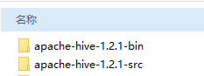

#### 创建Eclipse工程

新建Eclipse Java工程，命名为hive-hbase

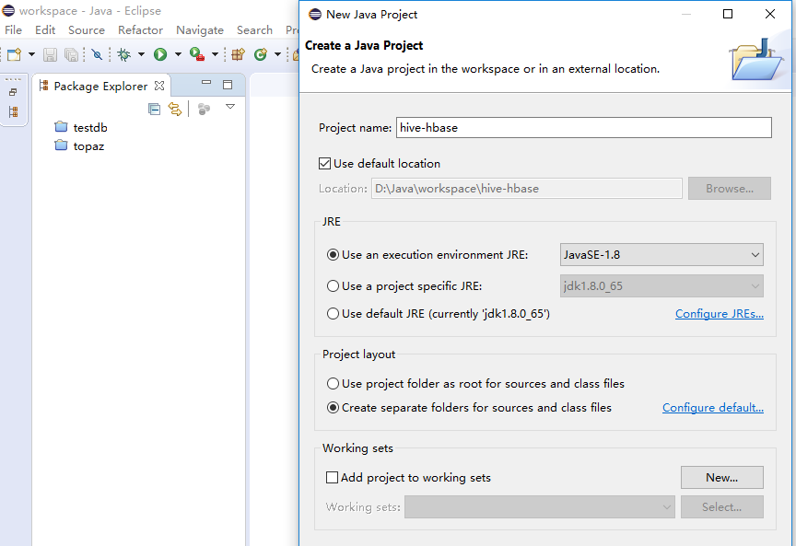

导入Hive Hbase Handler部分的源码

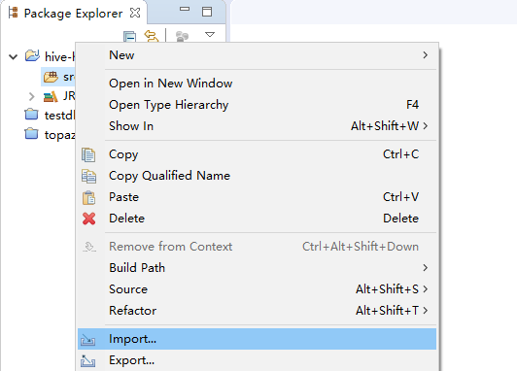

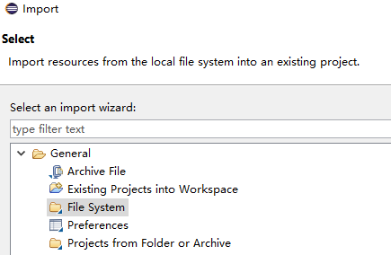

指定导入源码的目录

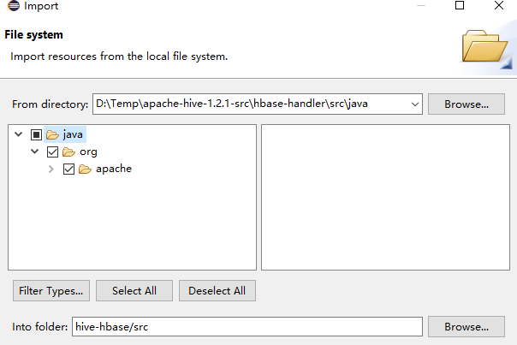

源码导入之后的工程项目结构

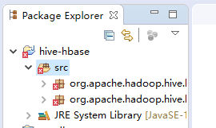

#### 引入相关Jar包与编译

引入如下14个Jar包到Eclipse工程中，Jar文件从Hadoop/Hive/Hbase安装目录中收集

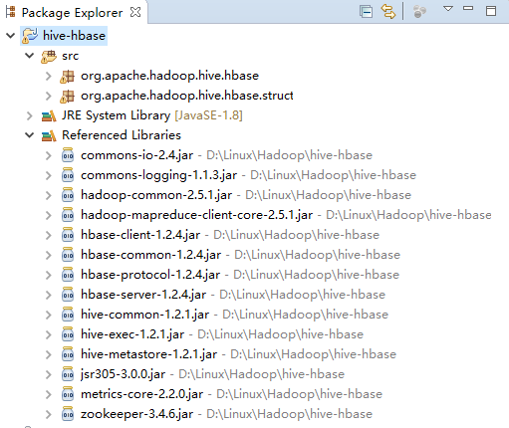

选中源码src目录，导出->Jar File，将目标文件命名为*hive-hbase-handler-1.2.1.jar*

**必须要用此文件名，与Hive的Lib目录下文件名一致**

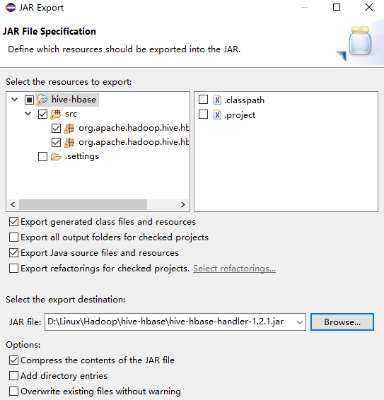

#### 更新Jar文件

将刚编译好的jar文件及前面依赖的14个文件上传到hive的lib目录下，覆盖现有文件。

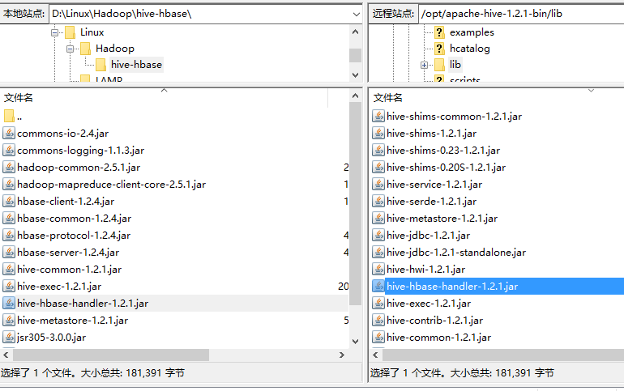

#### 修改Hive配置文件

|  |
| --- |
| [hadoop@hdp27 apache-hive-1.2.1-bin]$ vi conf/hive-site.xml  <property>  <name>hive.aux.jars.path</name>  <value>file:///opt/apache-hive-1.2.1-bin/lib/hive-hbase-handler-1.2.1.jar,file:///opt/apache-hive-1.2.1-bin/lib/guava-14.0.1.jar,file:///opt/apache-hive-1.2.1-bin/lib/hbase-common-1.2.4.jar,file:///opt/apache-hive-1.2.1-bin/lib/hbase-client-1.2.4.jar,file:///opt/apache-hive-1.2.1-bin/lib/zookeeper-3.4.6.jar</value>  </property>  <property>  <name>hbase.zookeeper.quorum</name>  <value>hdp27</value>  </property> |

#### 测试Hive与Hbase集成

|  |
| --- |
| [hadoop@hdp27 bin]$ hive  ls: cannot access /opt/spark-2.0.2-bin-hadoop2.7/lib/spark-assembly-*.jar: No such file or directory  Logging initialized using configuration in file:/opt/apache-hive-1.2.1-bin/conf/hive-log4j.properties  hive> CREATE TABLE hbase_table_1(key int, value string)  > STORED BY 'org.apache.hadoop.hive.hbase.HBaseStorageHandler'  > WITH SERDEPROPERTIES ("hbase.columns.mapping" = ":key,cf1:val")  > TBLPROPERTIES ("hbase.table.name" = "xyz", "hbase.mapred.output.outputtable" = "xyz");  OK  Time taken: 2.365 seconds  hive> drop table hbase_table_1;  OK  Time taken: 3.795 seconds |

### Python 3访问Hive

## Presto安装配置

### Presto体系架构

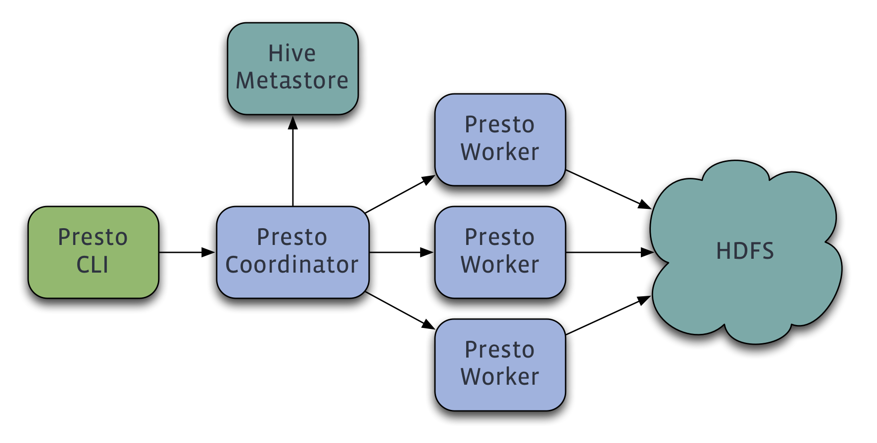

### Presto安装配置

#### 上传&解压Presto

|  |
| --- |
| [root@hdp27 install]# tar -xvzf presto-server-0.157.tar.gz  [root@hdp27 install]# mv presto-server-0.157 ..  [root@hdp27 opt]# chown -R hadoop:hadoop presto-server-0.157  [root@hdp27 ~]# mkdir -p /var/presto  [root@hdp27 ~]# chown -R hadoop:hadoop /var/presto |

#### 编写配置文件

|  |
| --- |
| [root@hdp27 ~]# su - hadoop  [hadoop@hdp27 ~]$ cd /opt/presto-server-0.157/  [hadoop@hdp27 presto-server-0.157]$ mkdir etc  [hadoop@hdp27 presto-server-0.157]$ vi etc/node.properties  node.environment=production  node.id=ffffffff-ffff-ffff-ffff-ffffffffffff  node.data-dir=/var/presto/data  [hadoop@hdp27 presto-server-0.157]$ vi etc/jvm.config  -server  -Xmx16G  -XX:+UseG1GC  -XX:G1HeapRegionSize=32M  -XX:+UseGCOverheadLimit  -XX:+ExplicitGCInvokesConcurrent  -XX:+HeapDumpOnOutOfMemoryError  -XX:OnOutOfMemoryError=kill -9 %p  [hadoop@hdp27 presto-server-0.157]$ vi etc/config.properties  coordinator=true  node-scheduler.include-coordinator=true  http-server.http.port=8080  query.max-memory=5GB  query.max-memory-per-node=1GB  discovery-server.enabled=true  discovery.uri=http://hdp27:8080  [hadoop@hdp27 presto-server-0.157]$ vi etc/log.properties  com.facebook.presto=INFO |

#### 配置Hive Connector

|  |
| --- |
| [hadoop@hdp27 presto-server-0.157]$ mkdir -p etc/catalog  [hadoop@hdp27 presto-server-0.157]$ vi etc/catalog/hive.properties  connector.name=hive  hive.metastore.uri=thrift://hdp27:9083 #修改为 hive-metastore 服务所在的主机名称，这里我是安装在Hadoop节点  hive.config.resources=/opt/hadoop-2.7.3/etc/hadoop/core-site.xml,/opt/hadoop-2.7.3/etc/hadoop/hdfs-site.xml |

#### 启动Presto

### Presto连接访问

## Sqoop安装配置

## Pig安装配置

## Tableau使用Spark SQL案例